DS10 Compilation Instructions

一 Environment Configuration
- 1. compilation environment

Please visit the following address to download the compilation chain package "owtoolchain.zip"
https://drive.google.com/file/d/1yVfltWdgUpjrMy-ondYa0T5ihrqVkj3v/view?usp=sharing

Extract the owtoolchain. zip file from the tool And put it on the C drive (compiler default path, Pay attention to the decompressed path) View the first line of build.bat in the demo
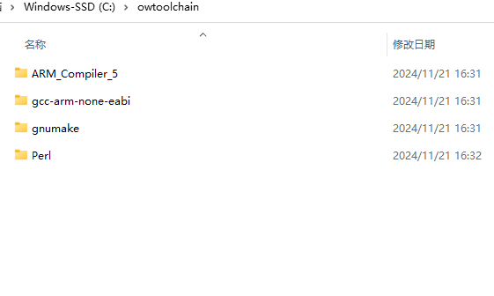
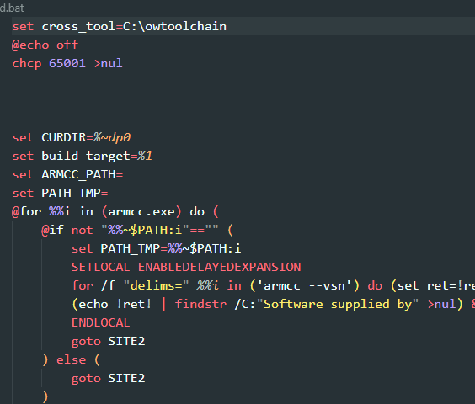
- Open the project directory, enter the demo directory, double-click project_build.bat

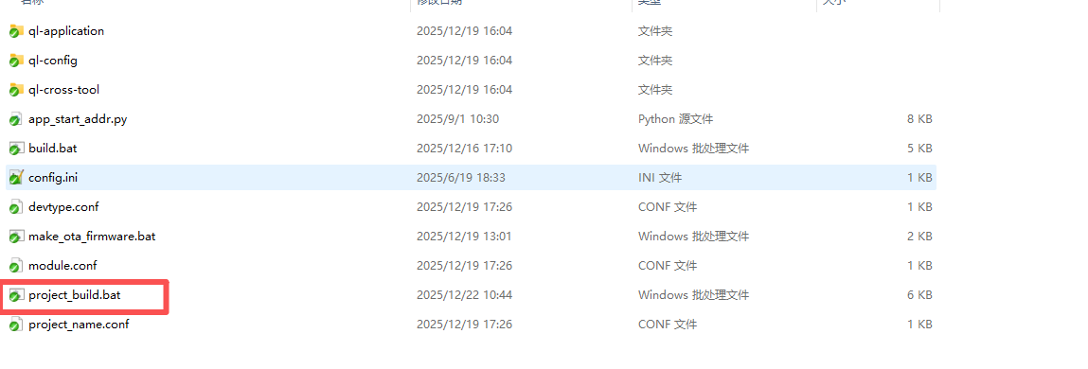
After running the script, the following window will pop up
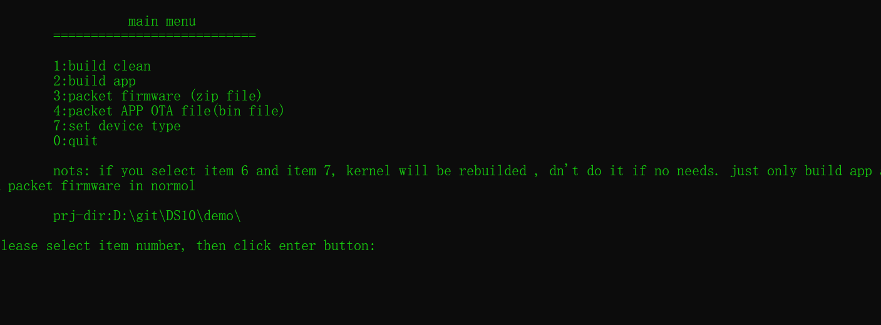
- Set the device type and enter the number 7 in the newly popped up window

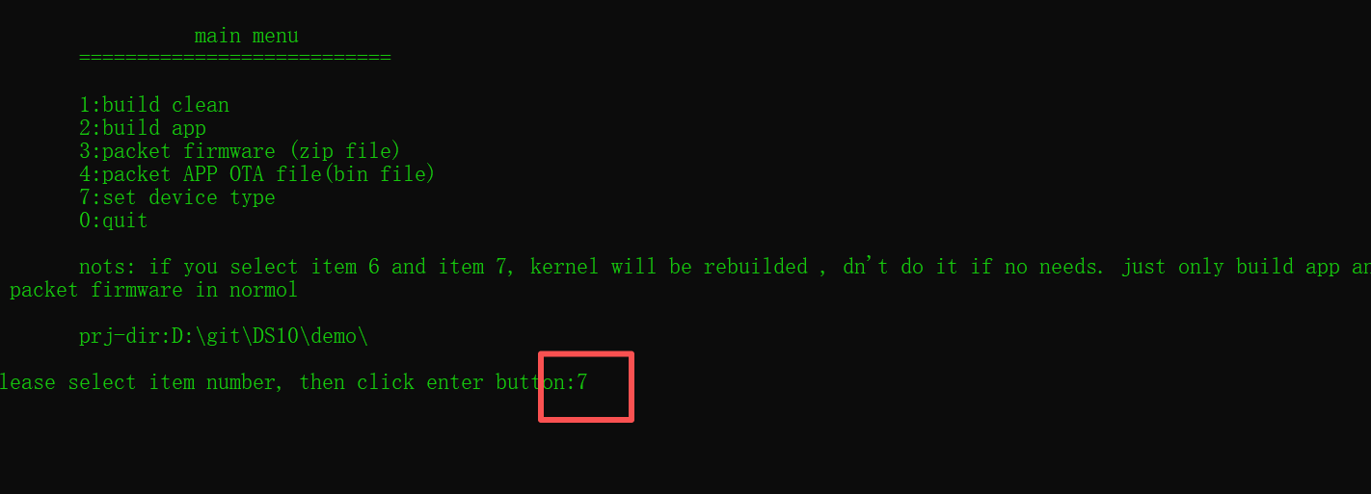

3 Choose different types based on your device hardware configuration
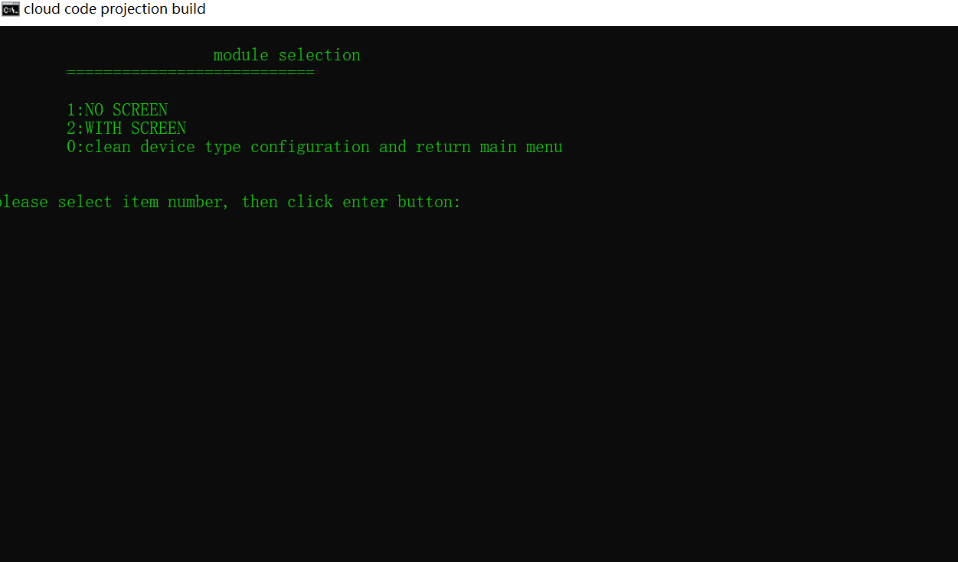
If the device has a screen, enter 2. If it does not have a screen, enter 1
Taking input 2 as an example, pressing the enter key after input will output the following message (please ignore the error message output)
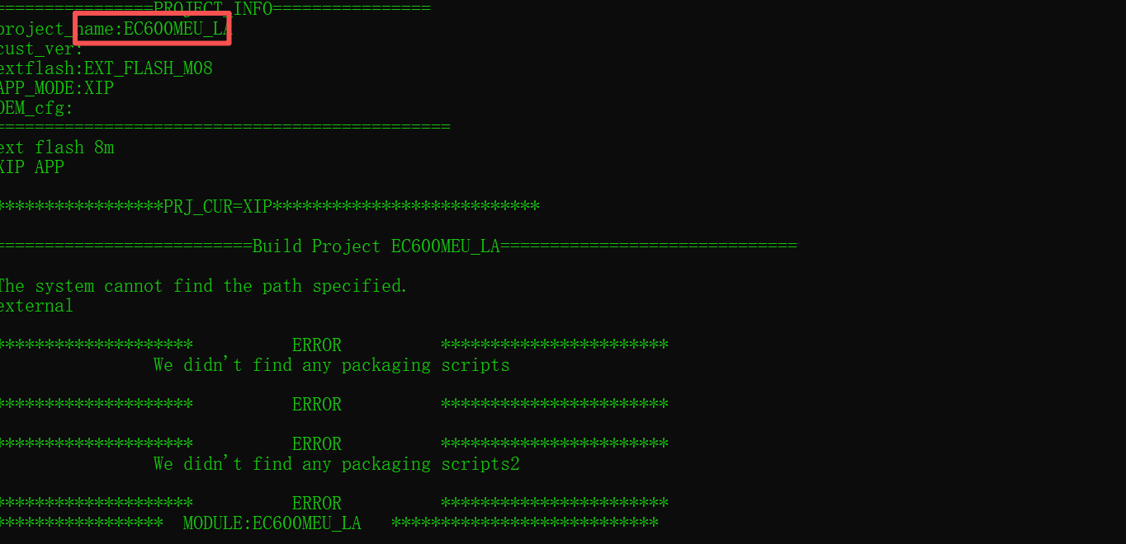
Continue pressing the enter key
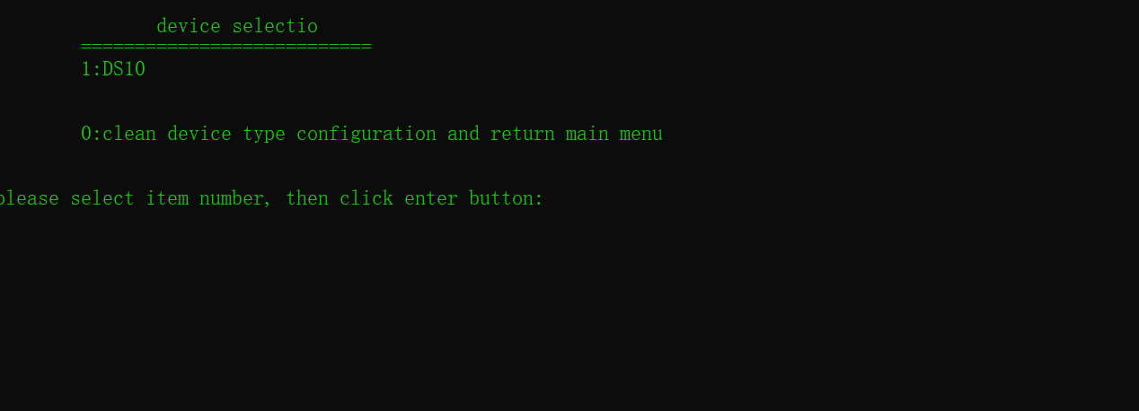
Enter 1 and press Enter
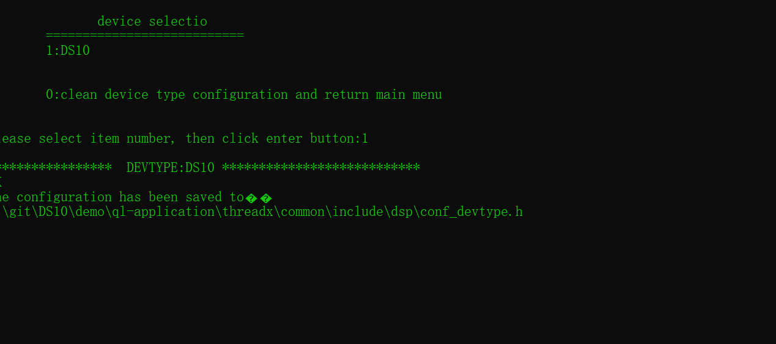
Continue pressing the enter key
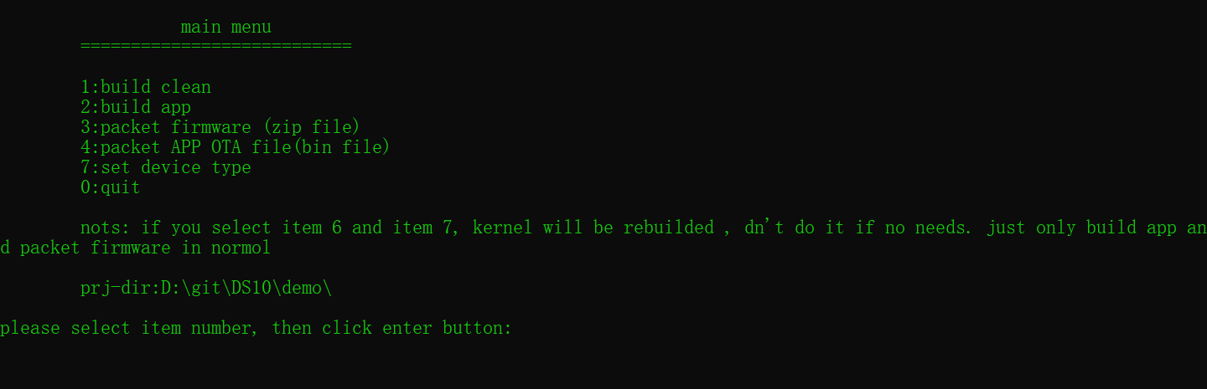
After entering the menu again, it indicates that the configuration has been completed

二 Compilation project
- During the first compilation, you can input 1 build clean to avoid leaving any other compiled information
- Enter 2 to build the app
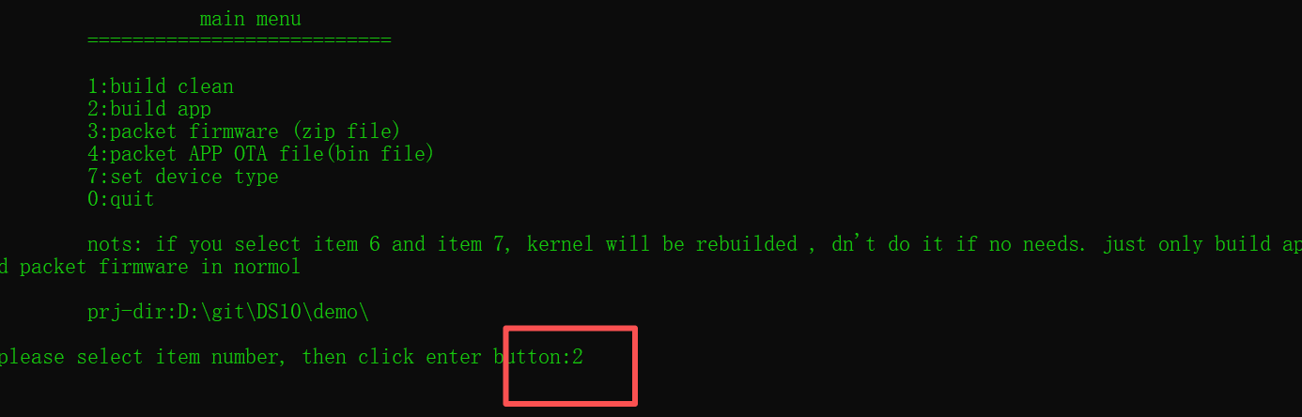
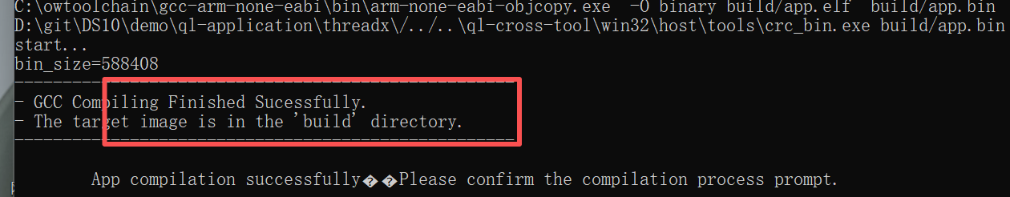
The above information indicates that the compilation was successful
- Pack the firmware, press Enter to return to the menu, and enter 3 packet firmware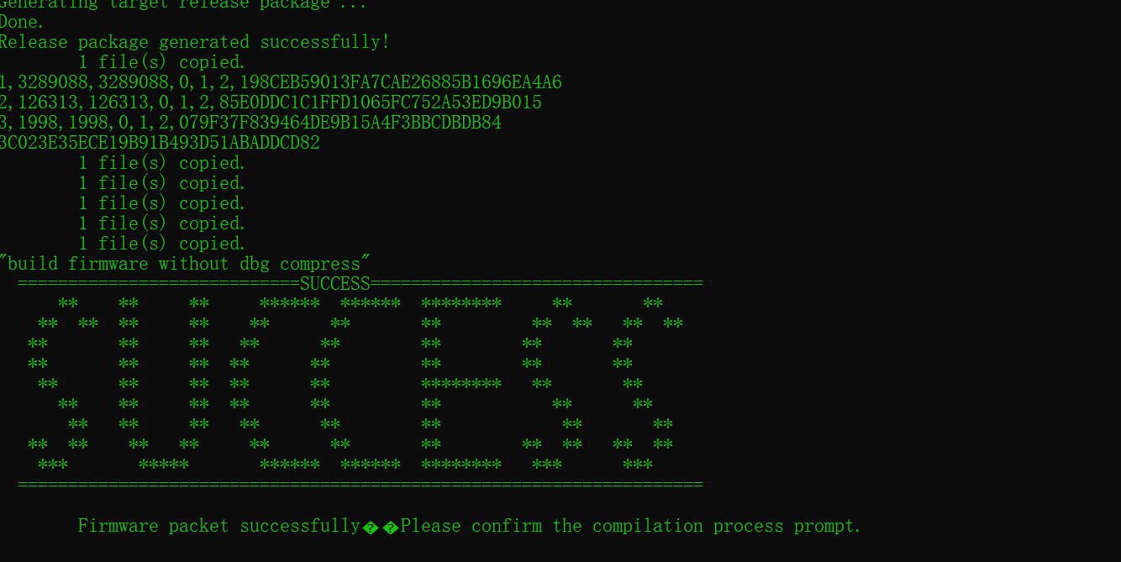
The above information indicates that the firmware has been successfully packaged.
The firmware file will be available. Generate a zip format firmware package under demo/target/DS10_4GW-V071501_100_S07A15_SC600MEU_LA

三 Firmware Download
- Run tool/download_tool/QMulti_SL_V2.6/QMulti_SL_V2.6.exe
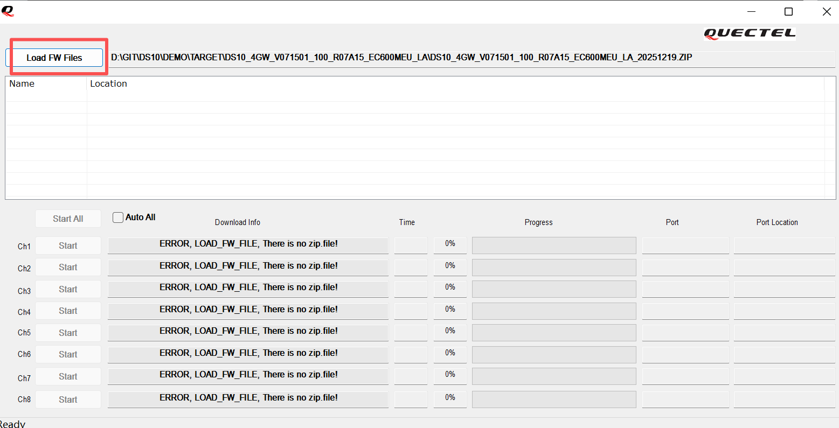

- Choose to generate a zip file
When the device is turned off, insert the USB cable and press the power button. The tool will detect the device status and start firmware download
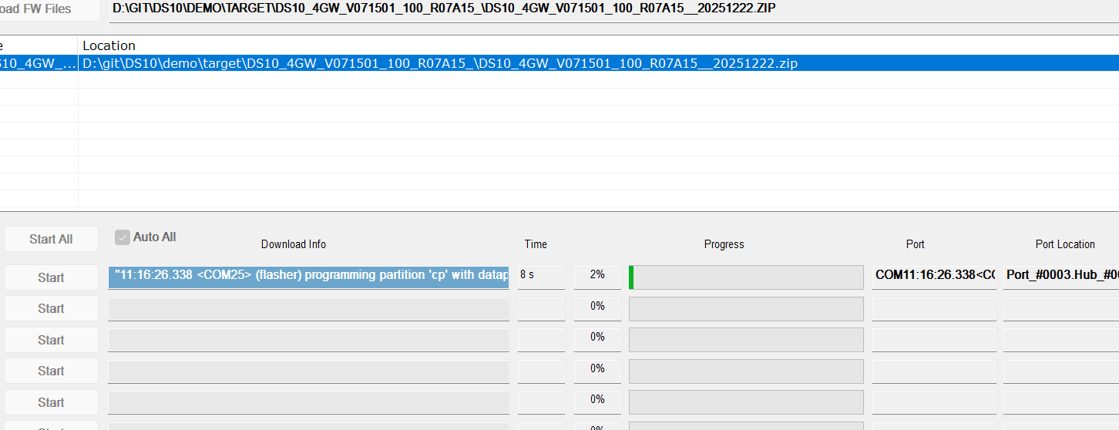
- firmware download success
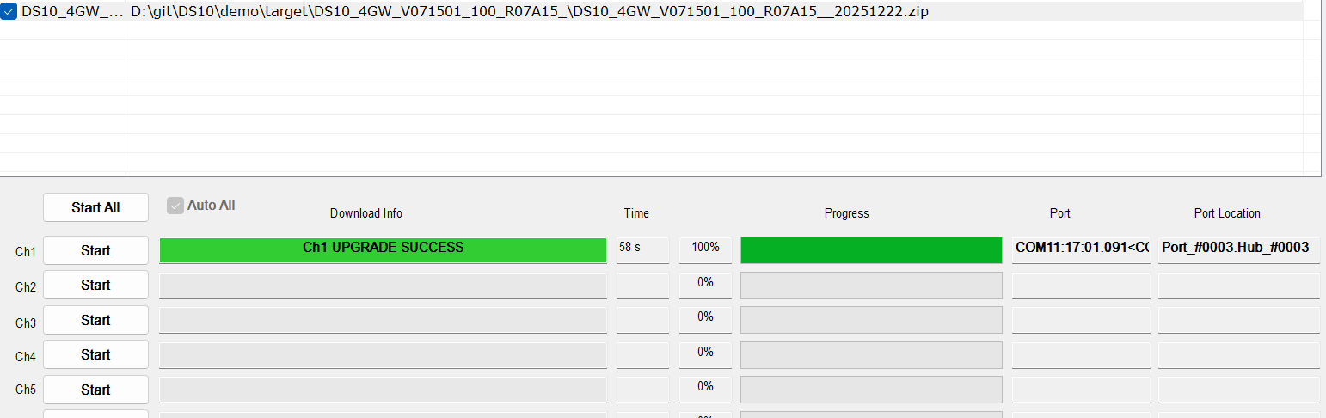
- Close the download tool and unplug the USB first, then press the power button to turn on the device, and the new firmware will run (Please note that the download tool must be closed, otherwise the device will enter download mode again)

四 Generate OTA firmware
You need to follow steps 2, 3, and 4 in sequence.
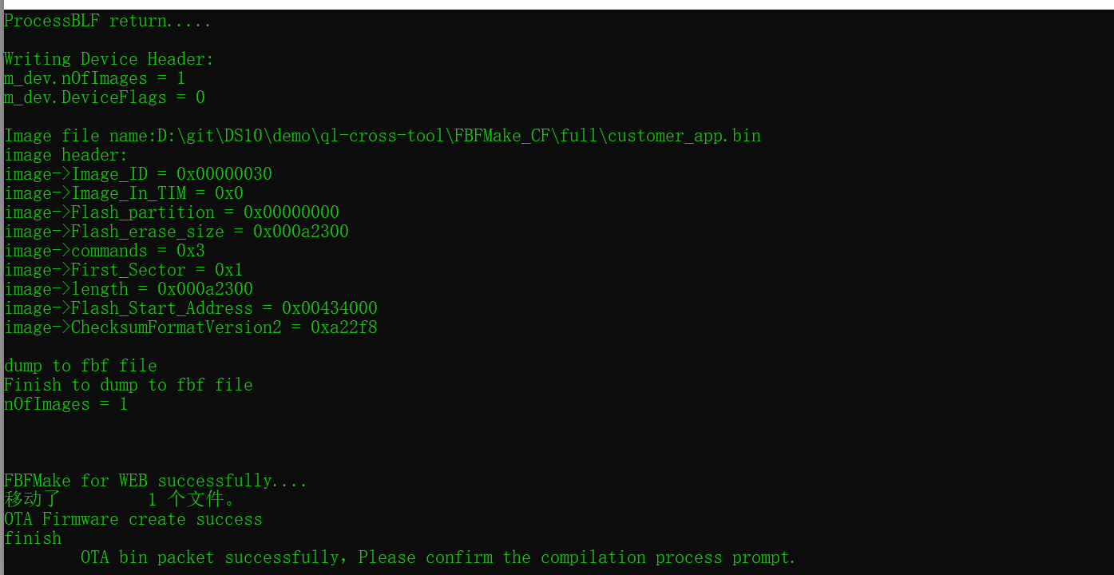
After the fourth step is successfully executed, OTA firmware will be generated in the current directory of the script It is a bin file.
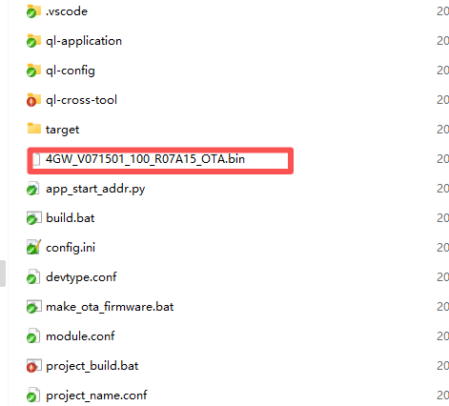
OTA firmware can be updated through TMS.

五 Debug Mode
- Install the usb driver. tool/driver/Quectel_Windows_USB_Driver(A)_Customer_V1.0.15.zip
- When the device is turned off, press and hold the function key and power key simultaneously to turn it on
- When hearing the broadcast 'enter factory mode', the device enters the setup mode
- Open system_parameters_setting_tool/ YM_ParamTool1.5.exe
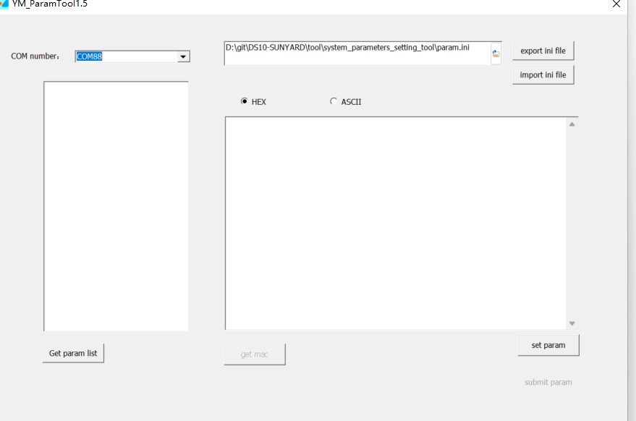
- The device will list 4 serial ports and select the first one Click the 'Get param list' button
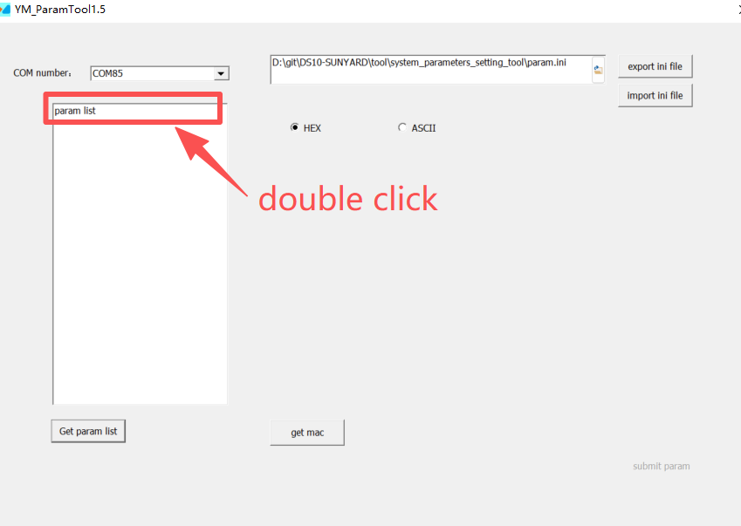

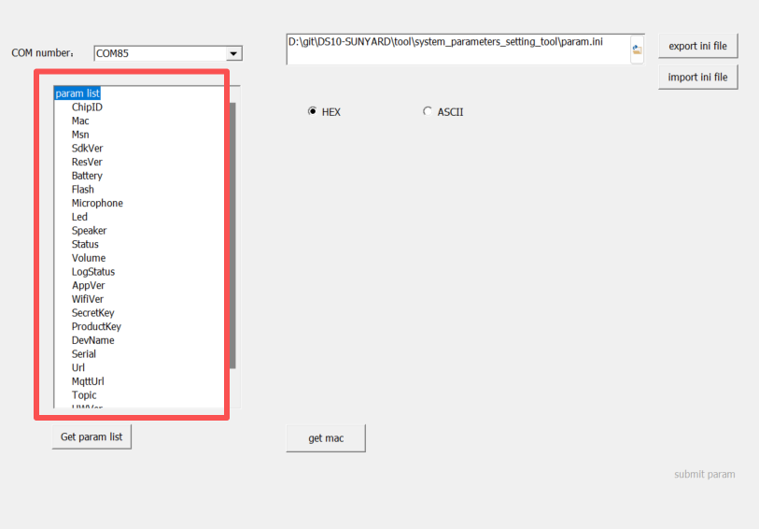
- Click on the LogStatus parameter
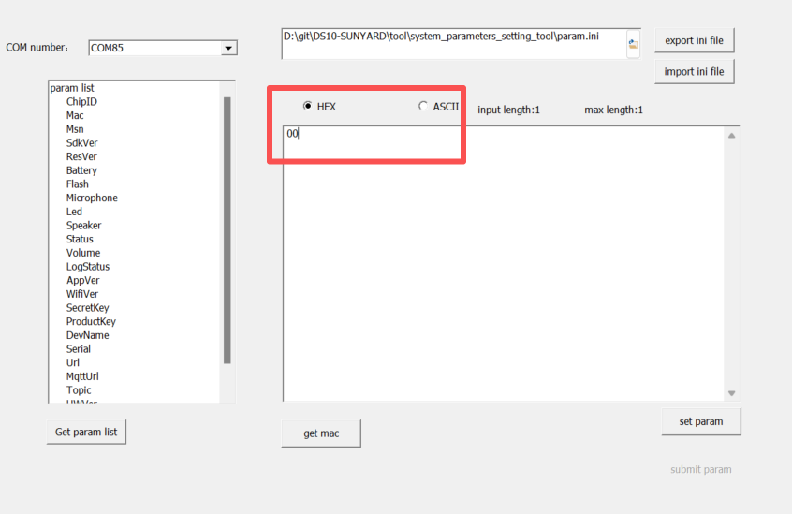
“00” Indicates release status, unable to retrieve logs Need to be changed to “02”

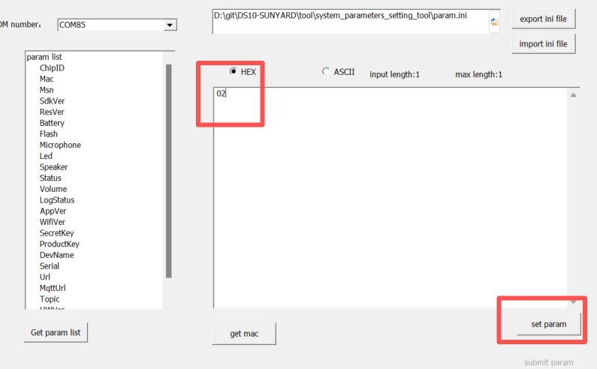
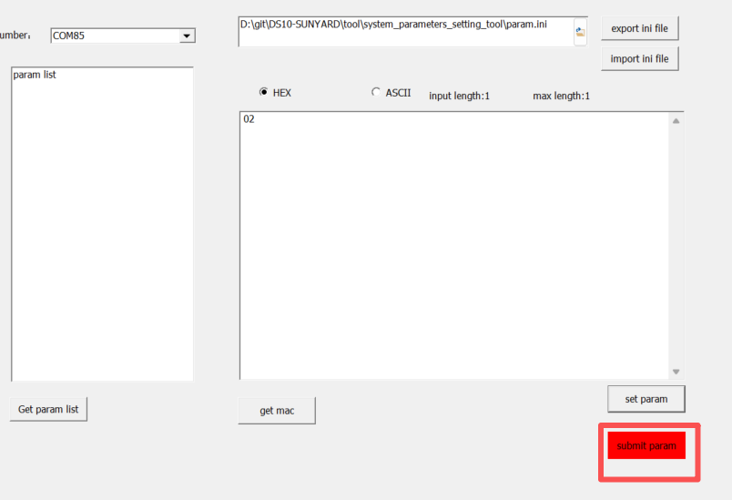
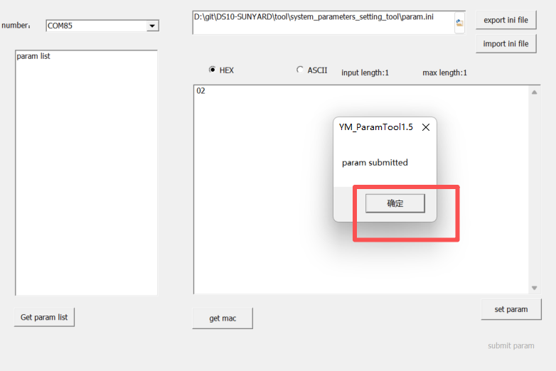
After clicking confirm, the setting was successful

- After clicking confirm, the setting was successful
After the device is turned on, it will first broadcast "welcome to cloud speaker", followed by a beep sound.
Open a serial port tool and select the first serial port for enumeration (along with the serial port for setting parameters)
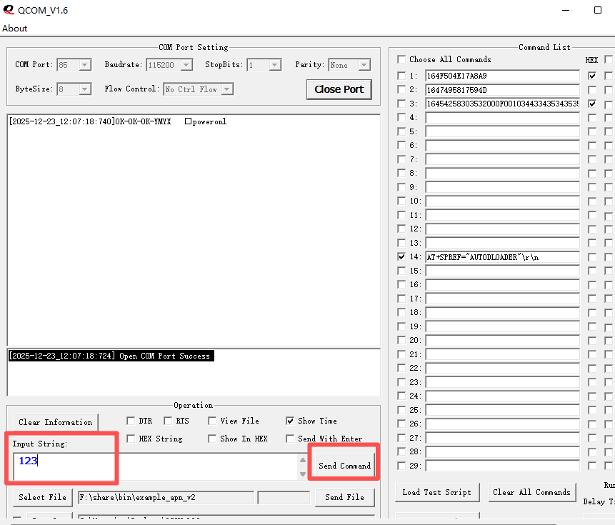
Enter any string in the sending area and click send
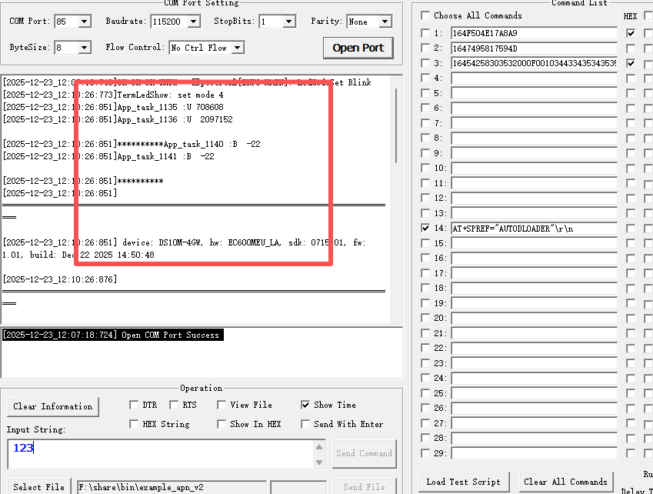
The serial port tool has log output

